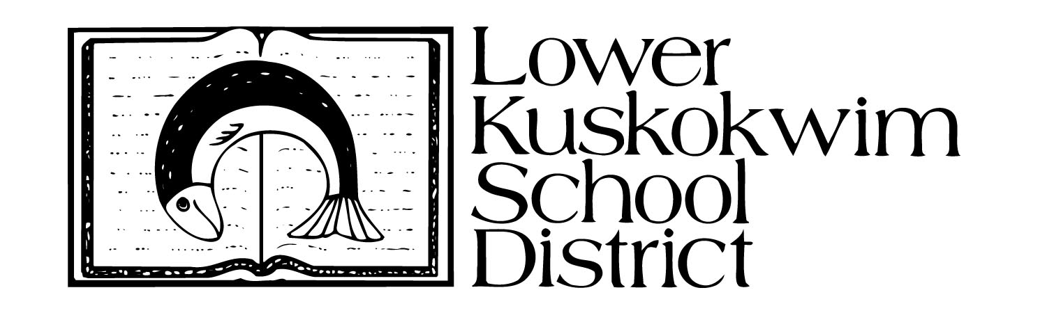Goods and Services
Rural Alaska GEAR UP Partnership
In-Kind Form Sample
Directions: Donors who provide in-kind donations of services, goods, supplies and travel should complete and sign this form.
Name: Kelly Queen - Manager |  | School District: Super School
 |  | School District: Super School District
Organization Name & Address:  Wal-Mart  123 Main Street  Anchorage, AK 99999 |  | Month & Year: September 2018
Date of  Contribution | Detailed Description of Services Rendered |  | # of  Hour(s) | Rate per  Hour ($) | Total
09/01/17 | Delivered donation to school |  | 0.50 | 28.99 | 14.50
 |  |  |  | TOTAL | 14.50
Date of  Contribution | Detailed Description of Goods and Supplies Provided |  | # of Unit(s) | Rate per  Unit ($) | Total
09/01/17 | Donated 250 pencils with college logos |  | 250 | 1.00 | 250.00
 |  |  |  | TOTAL | 250.00
Date of  Contribution | Detailed Description of Travel Incurred |  | # of Mile(s) | Rate per  Mile ($) | Total
09/01/17 | Miles driven to school |  | 10 | 0.535 | 5.35
 |  |  |  | TOTAL | 5.35
 |  |  |  | GRAND  TOTAL | 269.85
The information listed on this form is an accurate estimate of the services rendered, goods and supplies provided and travel
incurred that I have provided to the GEAR UP program. I hereby certify that this information is true and correct.
Kelly Queen 9/1/2018  X_ |  | X_
Contributor's Signature |  | Date
Complete, scan and send to: Victoria@rgicorporation.com. Originals submitted to local Principal.

