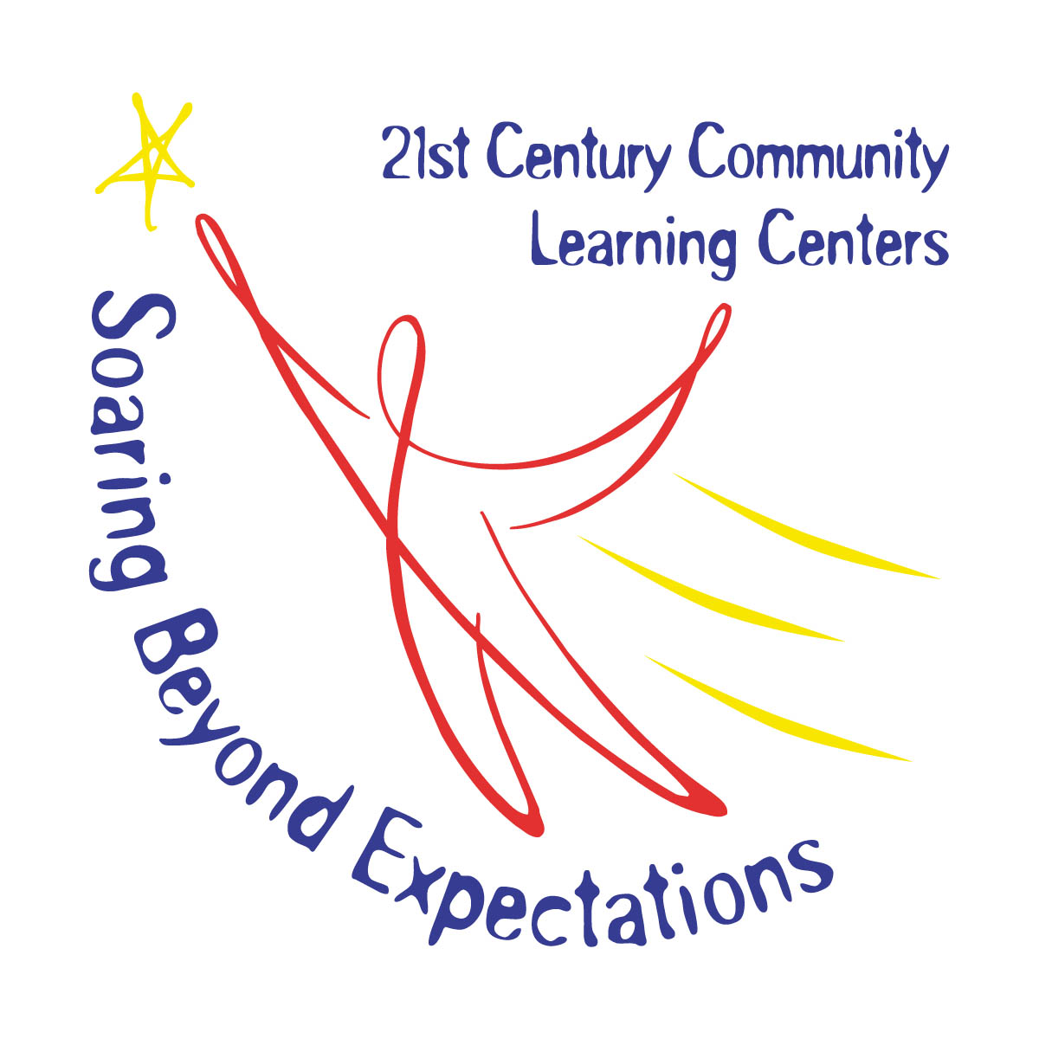21st Century Site Supervisor Monthly Report

Site Supervisor ______________________ Site ___________________ Month/Year ___________

Instructions – when completing the monthly narrative reports, we found that information addressing the following points is helpful in presenting a concise and including the key elements of your after school program. Please answer the following questions:

Afterschool Program

1) What was the number of days your program was offered during the month? (Please include dates)
2) What were the start and end times of the program and number of hours per week?
3) Describe your math, reading or other core educational components for the month.
4) What STEM activities did you offer this month? Please include a picture of an activity.
5) What other enrichment and support activities did your offer? Describe any of the following: nutrition, health, art, music, entrepreneurial education, telecommunications, technology, tutoring, mentoring, drug and violence prevention, character education, service learning or recreation.
6) What parent training activities occurred for the month and how many parents did you serve?
7) What was the number of students served in the month and their overall grade levels?
8) Did you have any collaboration with other organizations and programs in your after school program this month?
9) Please share an individual student success or site success story from this month. Please include a picture if applicable.

Quality Improvement

1) What are your specific goals for quality improvement? Have you made any progress meeting these goals?
2) What are you doing at the site level to improve the quality of your program?
3) What is the indicator you are working on for quality improvement? (YPQA Indicator)

Staff Development

1) Did you have any staff meetings this month? What was the objective of the staff meeting?
2) Did you provide any staff development this month related to your quality improvement goals?
3) Did any staff attend training specific to afterschool? If so, who provided it (OSPI, NCAC, SOWA, etc.)?

